**Landing page/Home!**

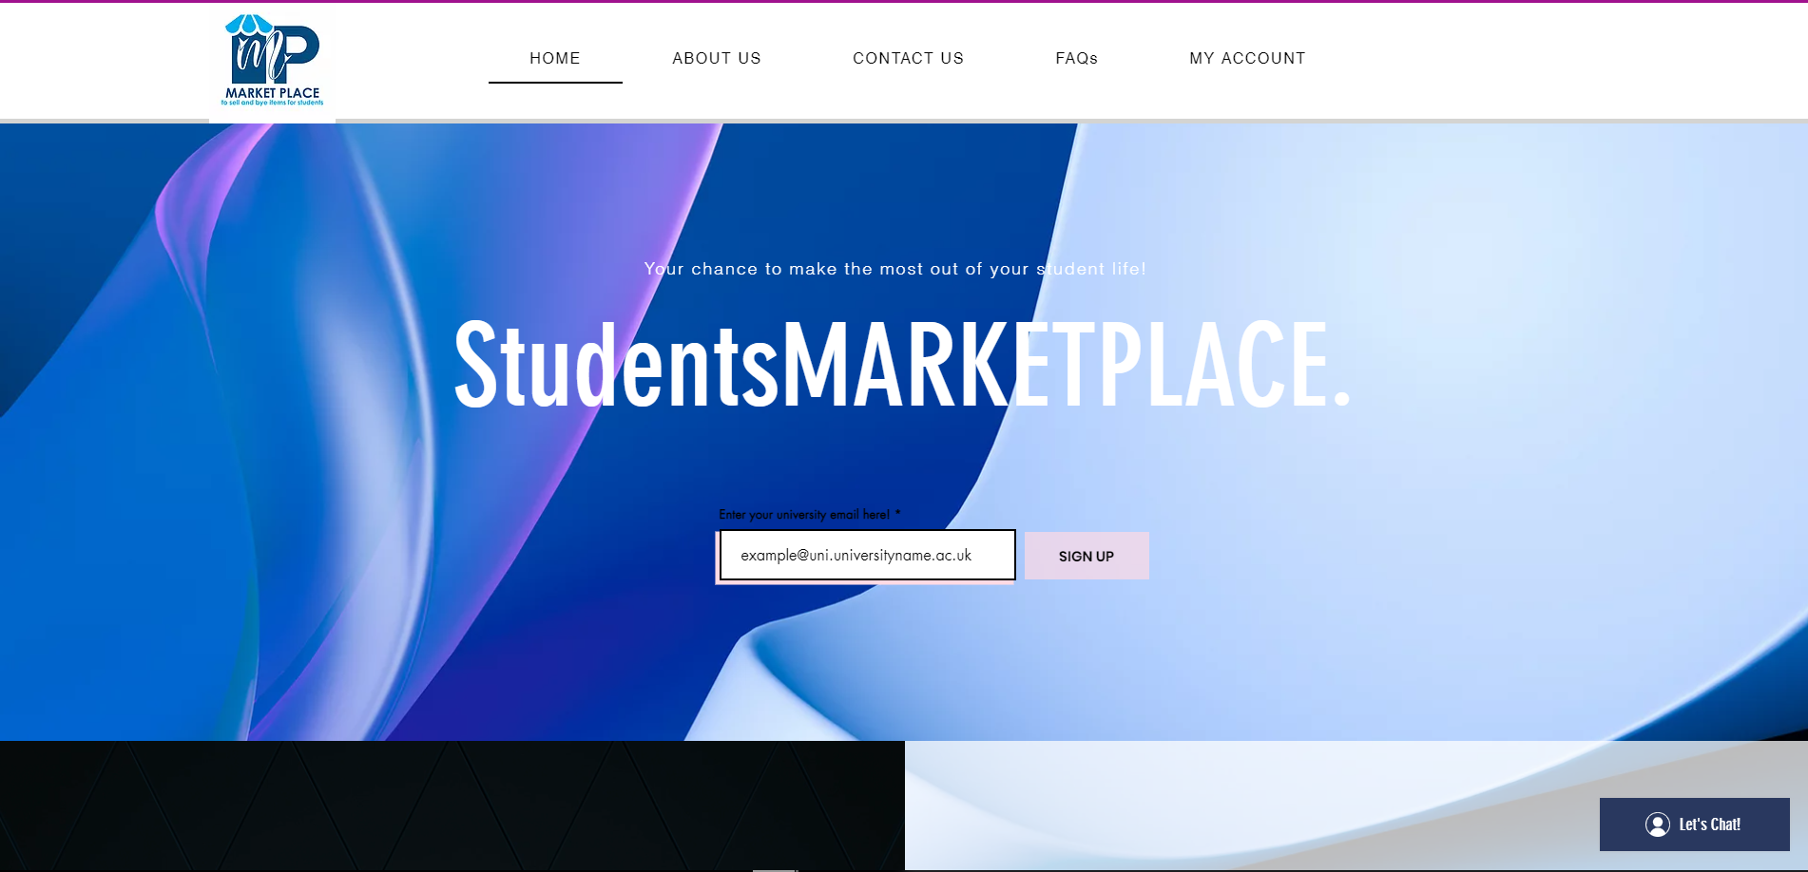

**About us page !**

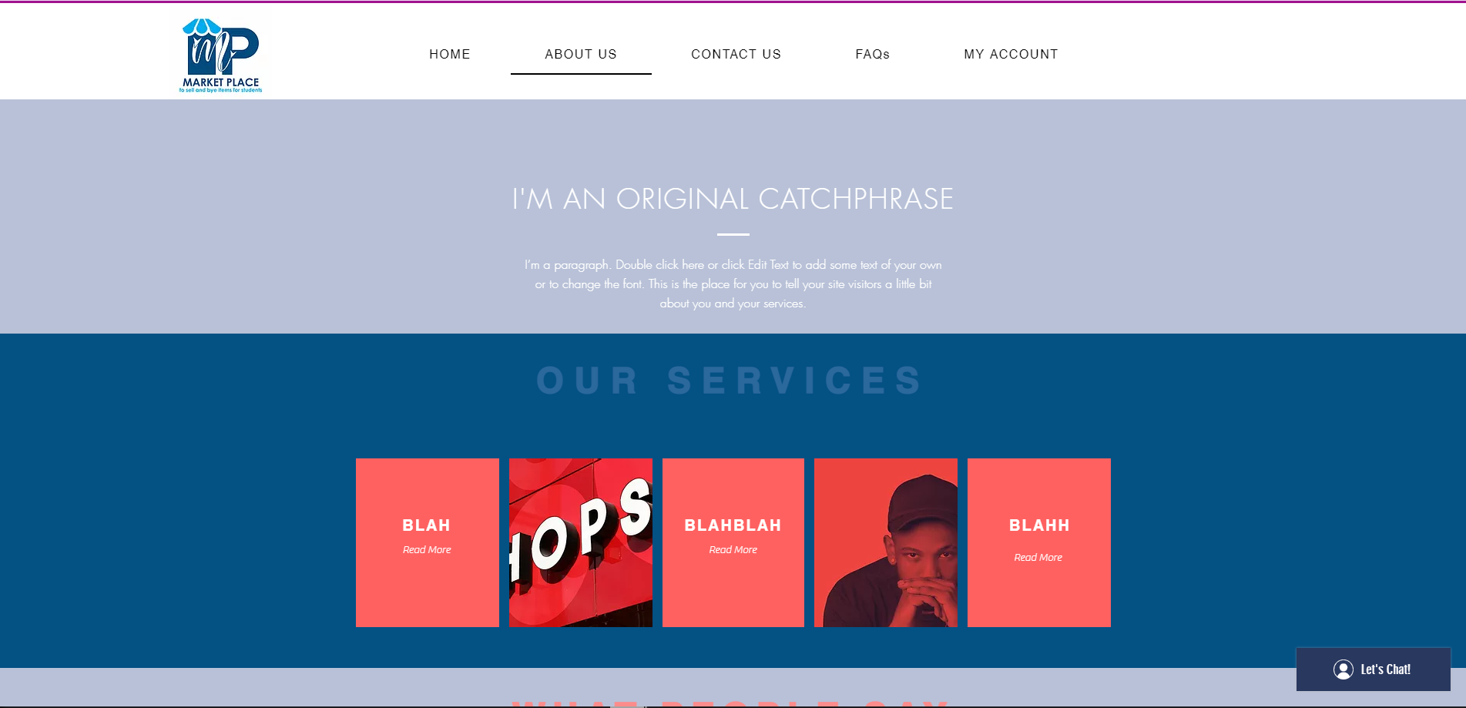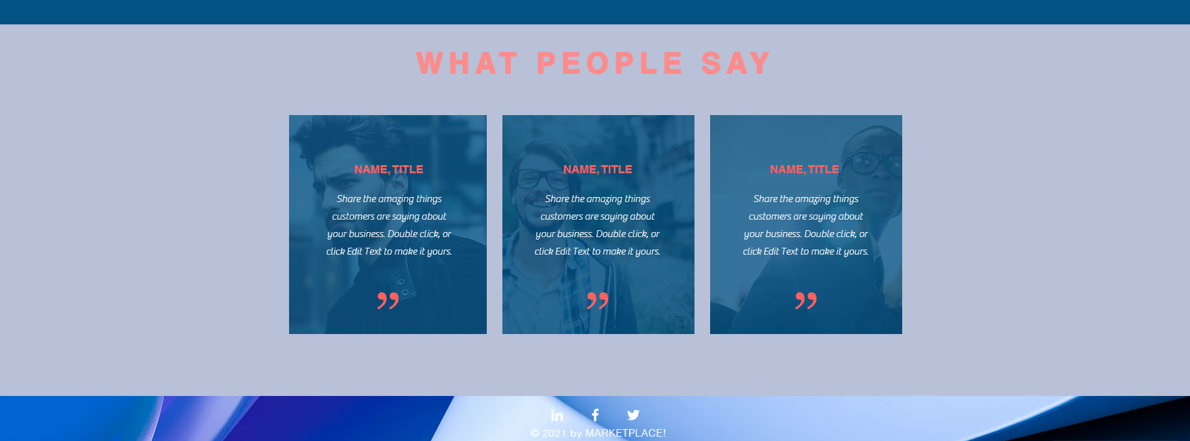

**Contact us page!**

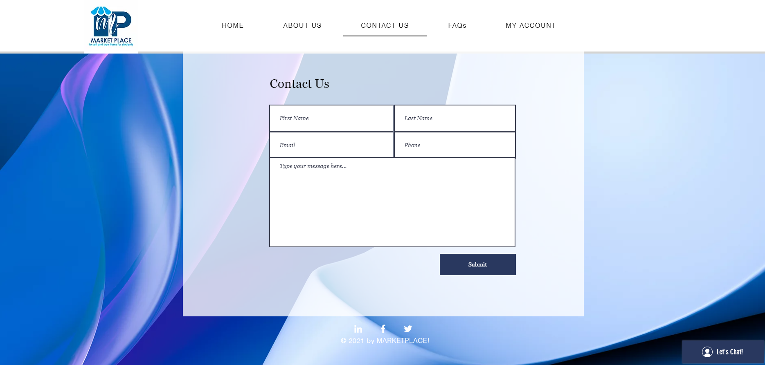

**FAQs page!**

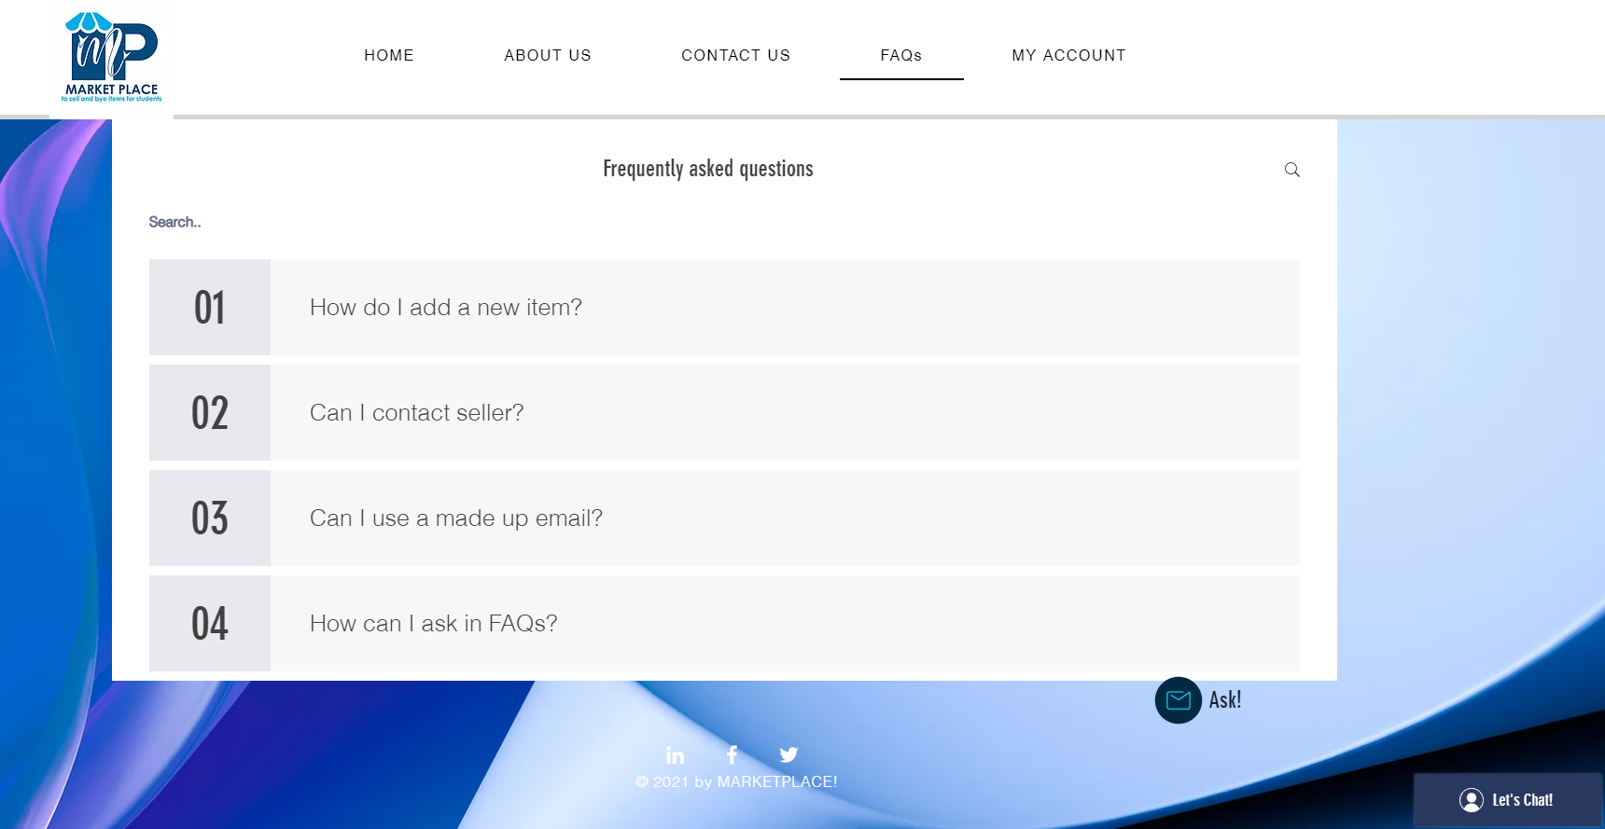

**My Account page!** --> only accessed if user is logged in otherwise popup window to suggest sign up / logging in etc...

!! On the left-hand side there is student housing ads!!

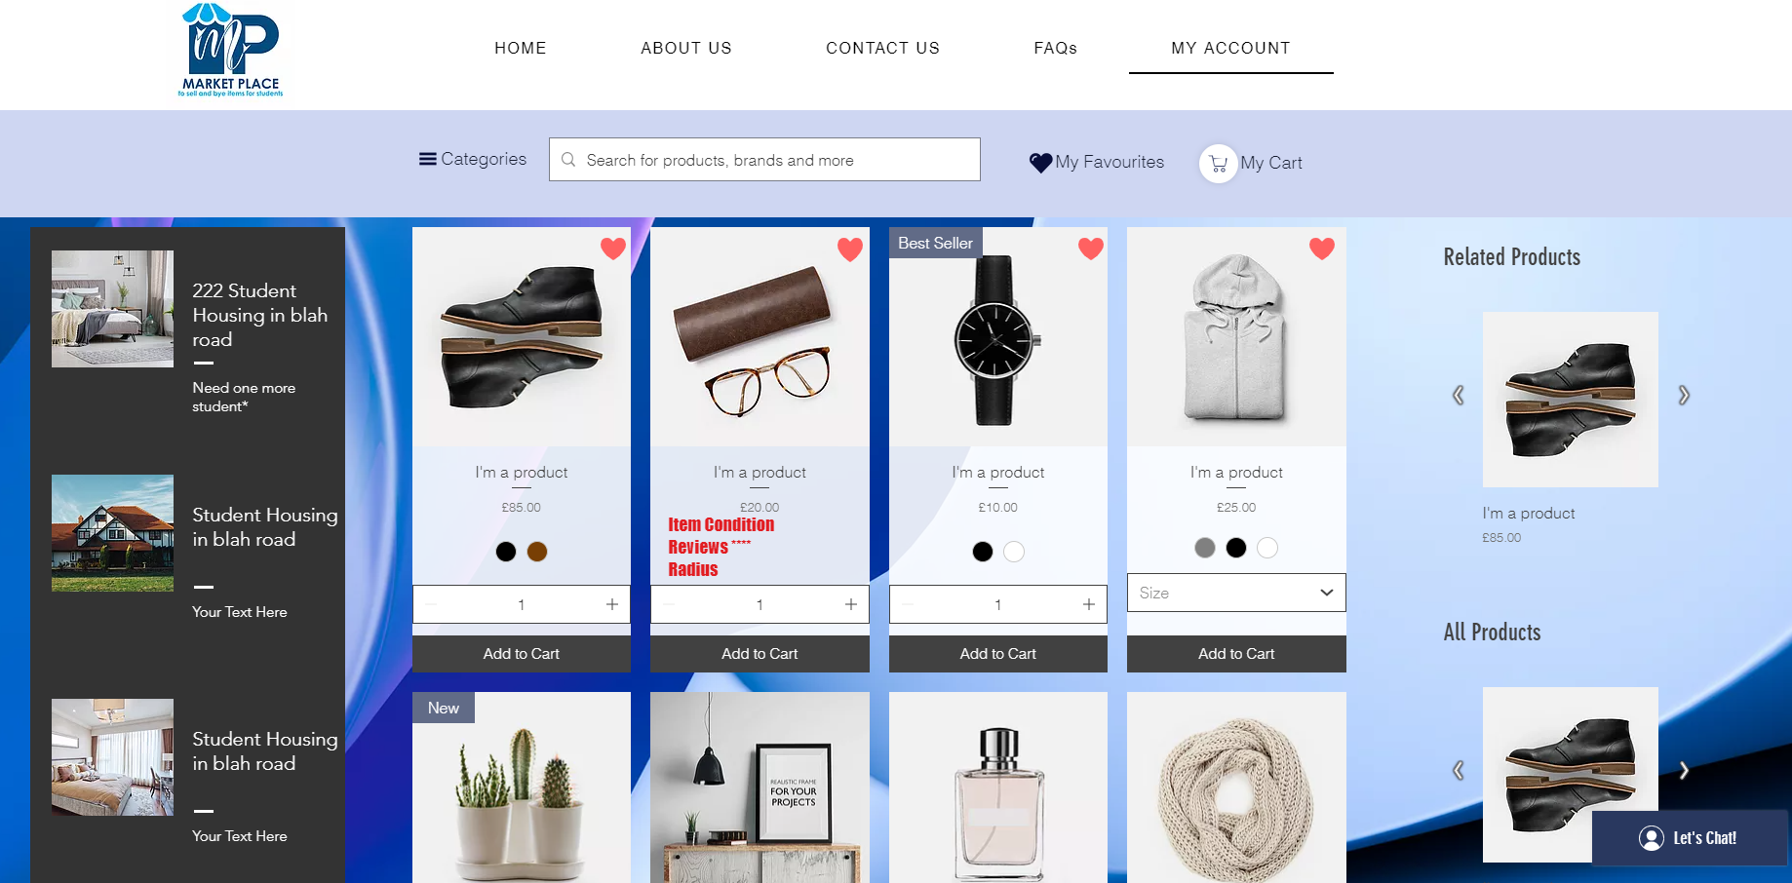

Can search by drop-down list in Categories --> 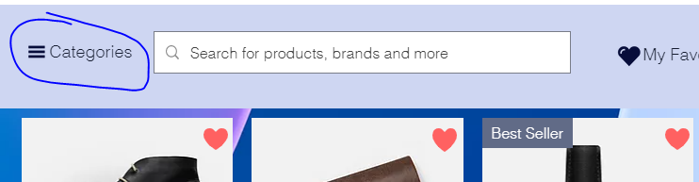

**Product page!**

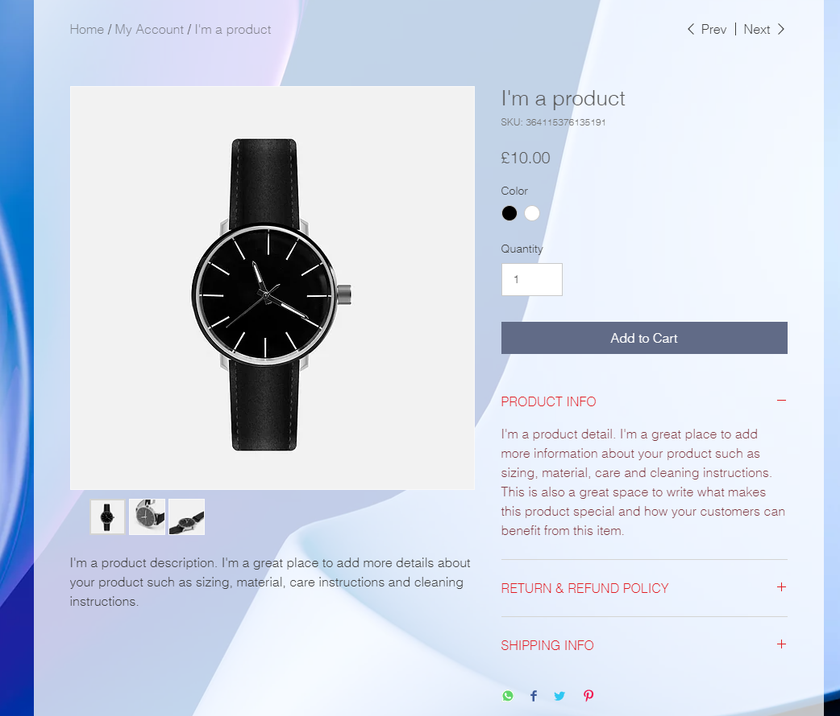

If customer clicks Add to Cart then a right side pop-up appears

